Guidewire Messaging.

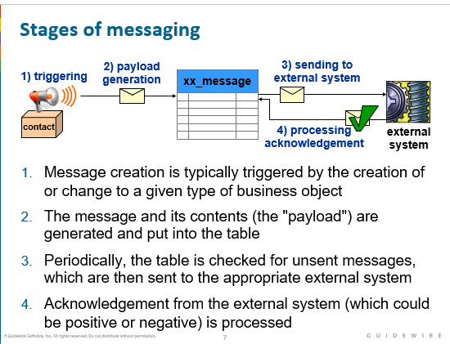

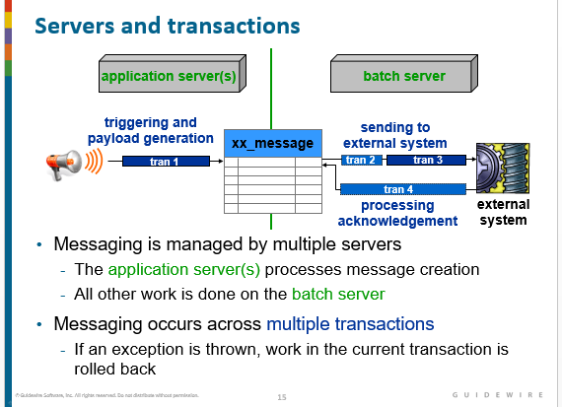

The servers involved at each point of the process are important because they determine where payload work should occur. The majority of payload generation should be done in Event Fired rules on the application server that manages the given user's session. However, if some portion of payload generation must be done immediately before the message is sent, that portion of the payload can be generated on the batch server. In clustered environments, only one application server can be the dedicated batch server. For this reason, the batch server typically does not manage user sessions even though this is possible. Batch servers can be configured also to manage message delivery and work queue threads. For non-clustered environments, the application server is also the batch server.

A message is always processed in at least two and as many as four transactions:

* 1. The first transaction (labeled as "tran 1" above) creates the message and generates the payload. This transaction always occurs.
  2. Prior to sending the message, an optional transaction (labeled as "tran 2" above) may transform the message payload. This is usually done when the message must include information that can only be known immediately before sending the message.
  3. The sending of the message to the external system occurs in its own transaction (labeled as "tran 3" above). This transaction always occurs. If the external system acknowledges the message synchronously, then the acknowledgement is included in this transaction.
  4. If the external system acknowledges the message asynchronously, then a separate transaction (labeled as "tran 4" above) processes the acknowledgement. This transaction does not occur for messages that are acknowledged synchronously.

The transaction structure is important because this determines the work that is rolled back if an error occurs.

**Sequence utility**: The is a Guidewire class that is used to generate unique, sequential numbers

Useful for business cases requiring numbers that are sequential or unique. The Guidewire database stores sequence information for each sequence; it maintains a record of the last number provided

The next () method is used to request numbers the database provides the next number in the given sequence

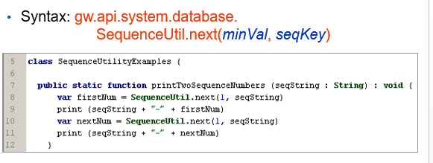

**ValueMomentum Interview**

Difference between Input set and Detail view panel?

**Can we create check or issue payment without exposure?**

Answer: Yes only Expense check not the medical one.

**What is matter ? What is subregation?**

Ans: Matter is an entity. Subrogation status is a type key, which the holds the values as review, open, closed.

**What are the limits for reserves?**

Answer: If there is no Medical or Indemnity exposure, you do not see them on the Reserve worksheet. You have to specifically add the limits on each claim. Without reserve worksheet, you can only issue expense check.

**Can we refresh the policy every time?**

We cannot refresh the policy in these situations.

Refresh the policy will not work if the risk units/coverage does not exist on the NEW / Updated policy.  You cannot refresh if the risk unit/coverage does not exist on the new policy and there are financial transaction associated to the risk unit / coverage.

So on P&C if a vehicle is removed from the policy - but we have a claim with that vehicle on the exposure and there are financial transactions on that exposure.  We cannot refresh